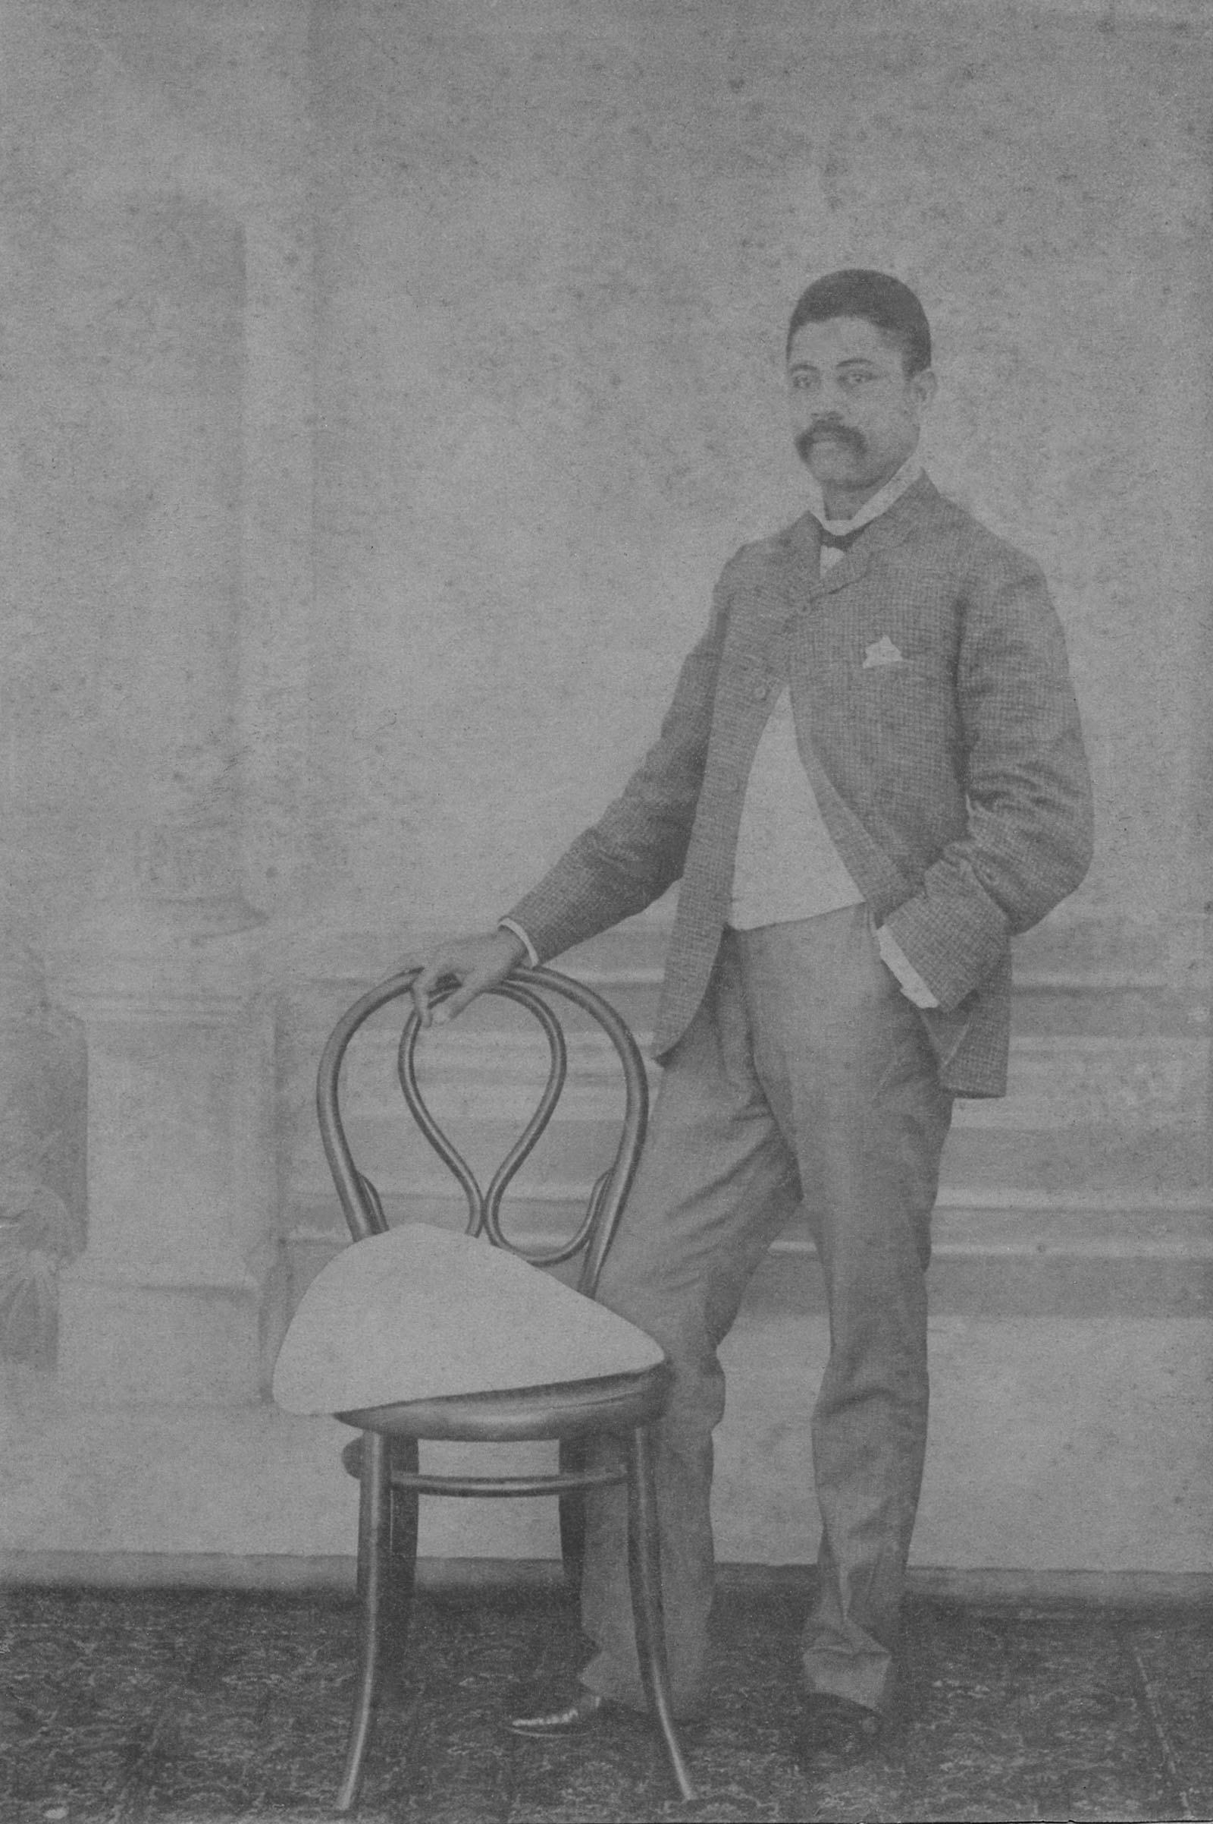

Kathleen's father, Dr. John Farrell Easmon. Probably his wedding portrait.

